

Informatics Institute of Technology
University of Westminster
Software Development Individual Project
5COSC021C.Y
CS -40
Module Leader- Banuka Athuraliya

Name :G.A.Lakindu Chandira Perera
UOW ID: W2051869
IIT ID:20231153
CS - 40

Declaration

By signing this document, I certify that this dissertation and all of its connected subcomponents are my original works and that none of them have previously been or are now being submitted to another university or other institution as part of a degree or other qualification program. Facts obtained from reputable outside sources have been properly acknowledged and credited.

Name of the Student : Gani Achchige Lakindu Chandira Perera

UOW No : 20231153

Iit No : W2051869

Signature: ………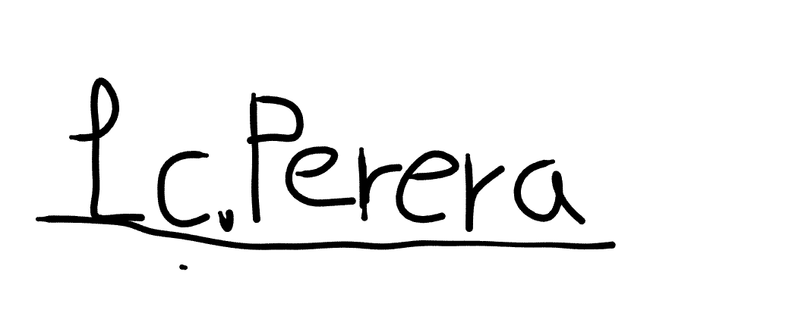… Date:.....19/11/2024.........

Abstract

Sleep is essential to maintaining health, affecting physical and mental well-being. But while most people hope to get a better night's sleep, many do not know how or why much less what it might take for them to improve theirs. An application that is data driven which will help in tracking, analyzing, and improving sleep by gathering easily accessible real-time data from wearable devices using machine learning algorithms.
The Application integrates with core sleep metrics, HRV, and activity data from popular wearable devices such as Fitbit & Apple Watch. It also includes user-reported data like sleep journals and medication use in order to provide personalized suggestions for better sleep hygiene. It uses predictive analytics using linear regression, to spot the trends and provocations, thus helping the users through predictable practitioners.

Keyword.

- Wearable devices
- Machine learning
- Random forrest regression
- Health Data analysis
- Predictive analytics
- Caffeine intake
- Service tier
- Business tier
- Data access tier
- Prototyping
- Brainstorming session
- Usability
- Scalability
- machine learning model
- Surveys/questionnaires
- Prototyping
- User authentication

Acknowledgment

To begin with, I wish to convey our heartfelt appreciation to our module leader, Mr. Banu Athuraliya, for his guidance and support during our journey. His readiness to share his knowledge has greatly improved the quality of our work.
I am incredibly grateful to our instructor, Mr. Mohamed Ayoob, for his guidance, patience, and ongoing support throughout this project. His valuable feedback and insightful advice have significantly influenced both this project and our academic growth.
A special thank you to our team members: Rusira Sandul, Nihla Nazim, Dewmi Jayasundara, Chalith Wickramasinghe, and Dulsara Abhiman. Their collaboration, enthusiasm, and support have been vital to the success of the project.
Lastly, I would like to express my gratitude to everyone who has provided guidance and encouragement throughout this journey. Your support has contributed to the success of this project.

List of content

List of content 5
Chapter 4: System Requirements Specification (SRS) 7
4.1 Chapter Overview 7
4.2 Stakeholder Analysis 8
4.2.1 Onion Model 8
4.2.2 Stakeholder Descriptions 9
4.4 Discussion / Analysis of Results 12
4.5 Use Case Diagram 13
4.6 Use Case Descriptions 13
4.7 Functional Requirements (with prioritization) 21
4.8 Non- Functional Requirements 22
4.9 Chapter Summary 23
Chapter 5: Social, Legal, Ethical and Professional Issues 24
5.1 Chapter Overview 24
5.2 Dataset Ethical Clearance 24
5.3 SLEP Issues and Mitigation 24
5.3.1Overview 24
5.3.2 Social issues 25
5.3.3 Legal issues 25
5.3.4 Ethical issues 25
5.3.5 Professional issues 25
5.4 Chapter Summary 25
Chapter 6: System Architecture and Design 26
6.1. Chapter Overview 26
The system architecture and design are covered in this chapter. Author made some important choices when designing the system. This chapter makes these choices very clearly. Author used information from the chapter on system requirement specifications to make these important design decisions. This chapter covered other potential design choices. 26
6.2. System Architecture Design 26
6.2.1 Presentation tier 28
The web application user interface is designed to provide an intuitive engaging interface for user. University students enter their inputs like sleep duration, average study hours, etc. then view their sleep quality prediction and interact with tools like user sleep journals, and analytics dashboards. 28
6.2.2 Service tier 28
6.2.3 Business tier 28
6.2.4 Data access tier 28
6.3.1.Class Diagram/Data Flow Diagram (DFD) 29
6.3.2.Sequence Diagram 30
6.3.3.UI Design and Mockups 30
6.3.4.Activity Diagram 32
6.4. Chapter Summary 32
References 33

List of Figures

Figure 1: Onion Model
Figure 2: LunaRest use case diagram
Figure 3: System Architecture Design
Figure 4:class diagram
Figure 5:Sequence diagram
Figure 6: UI design diagram
Figure 7: Activity diagram
Figure 8: survey questioaire
Figure 9: age responses chart
Figure 10: University year anyalyse chart
Figure 11: Average sleep duration in weekdays chart
Figure 12: Average sleep duration in weekends chart
Figure 13: Average study hours in weekdays chart
Figure 14: Average study hours in weekends chart
Figure 15: Average screen time chart
Figure 16: Daily caffeine intake chart
Figure 17: physical activity level charty
Figure 18: kaggle dataset

List of Tables

Table 1: Table 1: Stakeholder viewpoint Table
Table 2 : Selection of requirement Elicities methods
Table 3: Analyse table
Table 4: survey analyse table
Table 5: Track sleep data use case table
Table 6: set reminders use case table
Table 7: Sleep report generator use case table
Table 8: Recommendation receiving table
Table 9: generate the sleep patterns use case table
Table 9: generate the sleep patterns use case table
Table 10: update the data use case table
Table 11: user authentication use case table
Table 12: Functional requirements table
Table 13: Non Functional requirements table

Abbreviations table

AI | Artificial Intelligence
HRV | Heart Rate Variability
ML | Machine Learning
SRS | System Requirements Specification
API | Application Programming Interface
SLEP | Social, Legal, Ethical, and Professional
GDPR | General Data Protection Regulation
HIPAA | Health Insurance Portability and Accountability Act
CCPA | California Consumer Privacy Act
UI | User Interface
DFD | Data Flow Diagram
FR | Functional Requirement
NFR | Non-Functional Requirement
CC BY-SA | Creative Commons Attribution-ShareAlike

Chapter 4: System Requirements Specification (SRS)

4.1 Chapter Overview
This section investigates the functional and non-functional requirement aspects of the AI-enhanced sleep quality predicting web application targeted at university students. The paper were elicited, and evaluates the findings of this analysis, reaching a detailed comprehension of the system's overall architecture and its components’ behavior.

4.2 Stakeholder Analysis

4.2.1 Onion Model

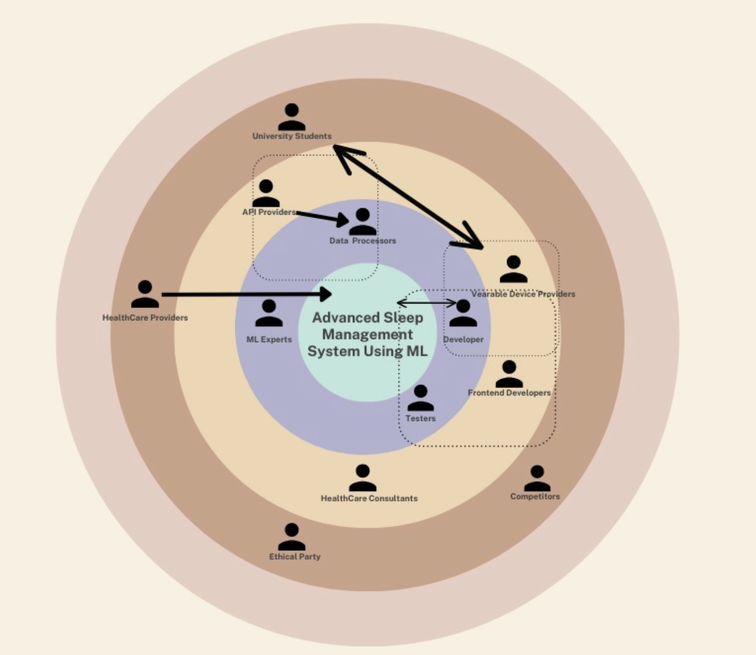
Figure 1: Onion Model

4.2.2 Stakeholder Descriptions
Stakeholder | Viewpoint
Functional beneficiary
University Students | They directly use the application for get sleep quality prediction and recommendation.
Financial beneficiary
API providers | Earn some income from API integration
Wearable device providers | Earn some income by selling devices
Social beneficiary
HealthCare consultants | Can use the information for the betterment of public health policies
Operational beneficiary
Developers | Build, maintain, and store the data of the system
Negative Stakeholders
Competitors | Have a threat to the app’s capability then losing the market share.
Regulatory
None
Experts
ML Experts | Explain about the what is the best regression. And give advice to improve the model accuracy.
Health Providers,researchers | Giving a professional knowledge about sleep quality.
Neighboring systems
None

Table 1: Stakeholder viewpoint Table (self composed)

4.3 Selection of Requirement Elicitation Techniques/Methods

The process of acquiring relevant project needs using a variety of instruments or methodologies is known as requirement elicitation. This section discusses a few of these options , as well as whythey were chosen for use in this project. Literature reviews, prototypeing and formal interviews are among the subject explored.

The AI-driven sleep quality prediction web app need to gather details information from stakeholders(university students,doctors, technical experts) the goals is to understand the users’ needs for the app as well as gather the correct data and develop the precess.

Method 1: Surveys/Questionnaires
- Purpose: Collect a large amount of university students about their sleep habits, study habits, and physical activity.
- Methods: send the Google form to get the anonymous students' data.(Sleepless Nights? Let’s Fix That!, 05/09/2024)
- Benefit: Quick and low-cost method for obtaining structured data from big audiences.

Method 2: Interviews
- Purpose: get motivation and professional advice on what we should improve our project
- Method: Meet a insomnia doctor or a research team.
- Benefits: get a deep knowledge of the topic.
Method 3: Prototyping
- Purpose: Evaluate how users interact with a web app design and features
- Method: Create a prototype using Figma and get student group feedback about the app.
- Benefits: get to know about usability issues.
Methods 4: Brainstorming Session
- Purpose: to generate new ideas and solutions using help from stakeholders.(experts, supervisors)
- Method: Organized brainstorming meetings will be conducted with key stakeholders.
- Benefits: it helps to improve the app features.
Table2 : selection of requirement Elicities methods (self composed)

4.4 Discussion / Analysis of Results

Method 1: Survey/Questionnaire
Get a comprehensive understanding of students’ sleep habits, study patterns, and lifestyle factors. This structural data helps for statistical analysis, the relationship between sleep quality and factors like caffeine intake, physical activity, etc. According to the survey, most of the students do not get sufficient sleep because of long study hours and screen time. High caffeine consumption was found to be strongly associated with poor sleep quality.
Additionally, this will help to train a model of Machine Learning.

Only IIT students were included in the survey sample, which might have an impact on how broadly applicable the results are. To overcome this restriction, future iterations will try to increase the sample size.
(Sleepless Nights? Let’s Fix That!, 05/09/2024)

Method 2: Interviews
Interviews with insomnia doctors and research teams offered professional insights.
This discussion depends on the people's understanding of this problem.
Method 3: Prototyping
user feedback on the prototype shows challenges. prototyping allows to early detection the design flaws and provides actionable insights. This helps to final project become more attractive for the user.

Table 3: analyse table

4.4.1 Questionnaire research

Question | Response | Analyse
Age | 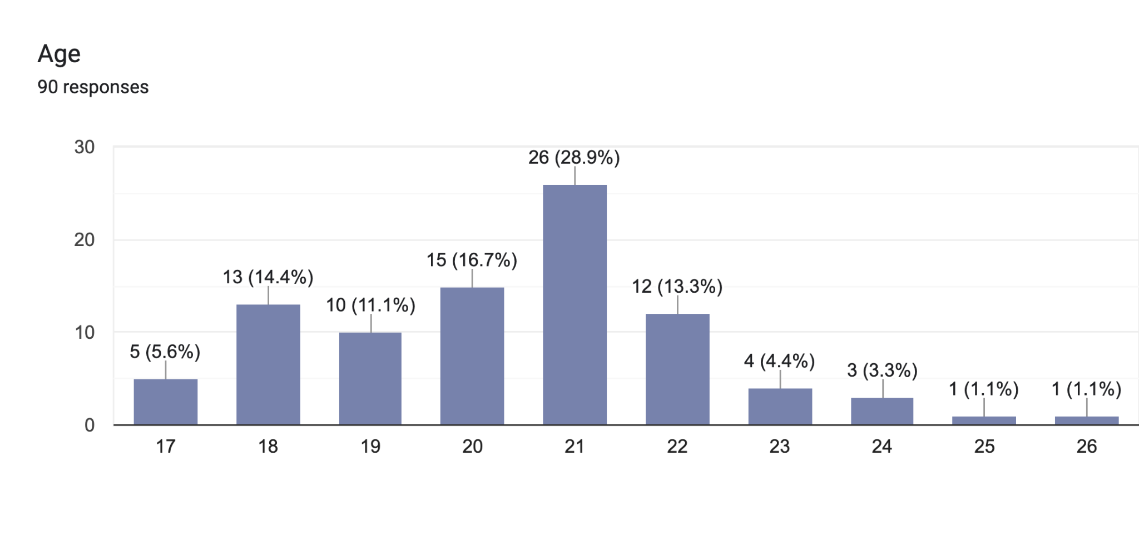 | According this chart most of the students are in age of 21. Others are in age 17 to 26. According this all the students are in university year 1 to 4.
Gender | 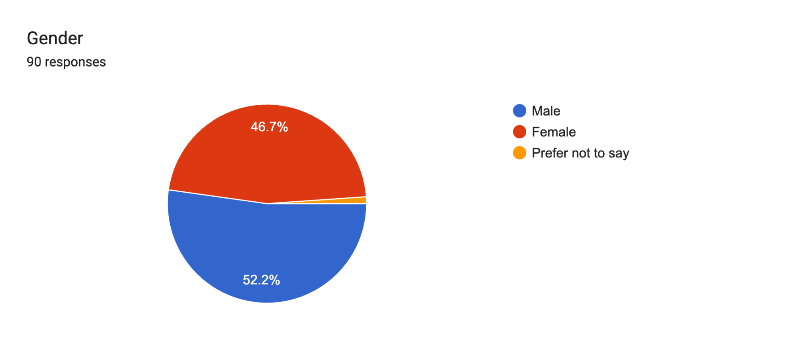 | According this pie chart most of the students who fill this google form are male.
University Year | 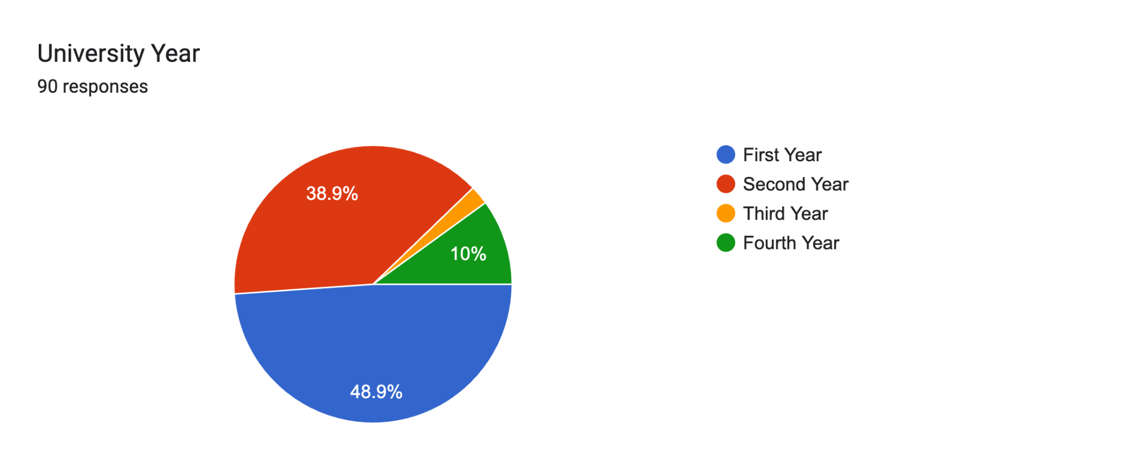 | According this graph most of students who fill this chart are first year students.
Average sleep duaration | 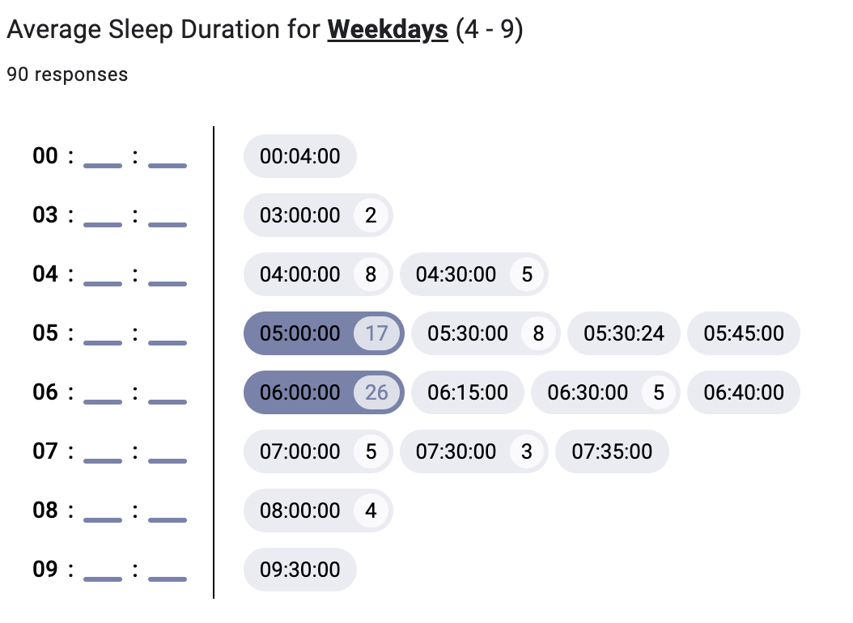  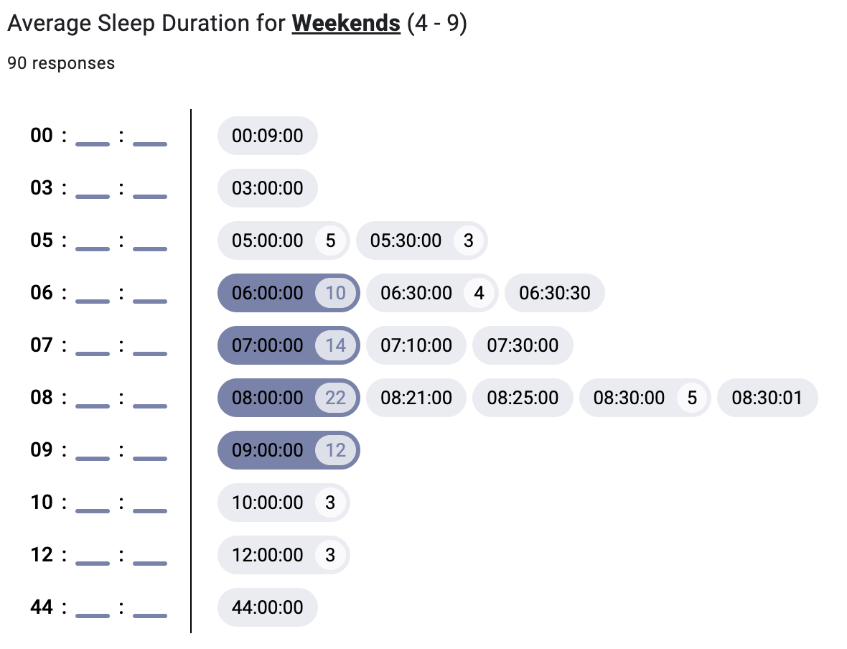 | The length of sleep on weekdays and weekends is entered into the Google form. because the Google form's user finds it challenging to complete the seven days. Because weekends are free, the majority of individuals sleep properly on weekdays and properly on weekends.  Average sleep hours = (average sleep hours weekdays + average sleep hours weekends) / 2
Average study hours | 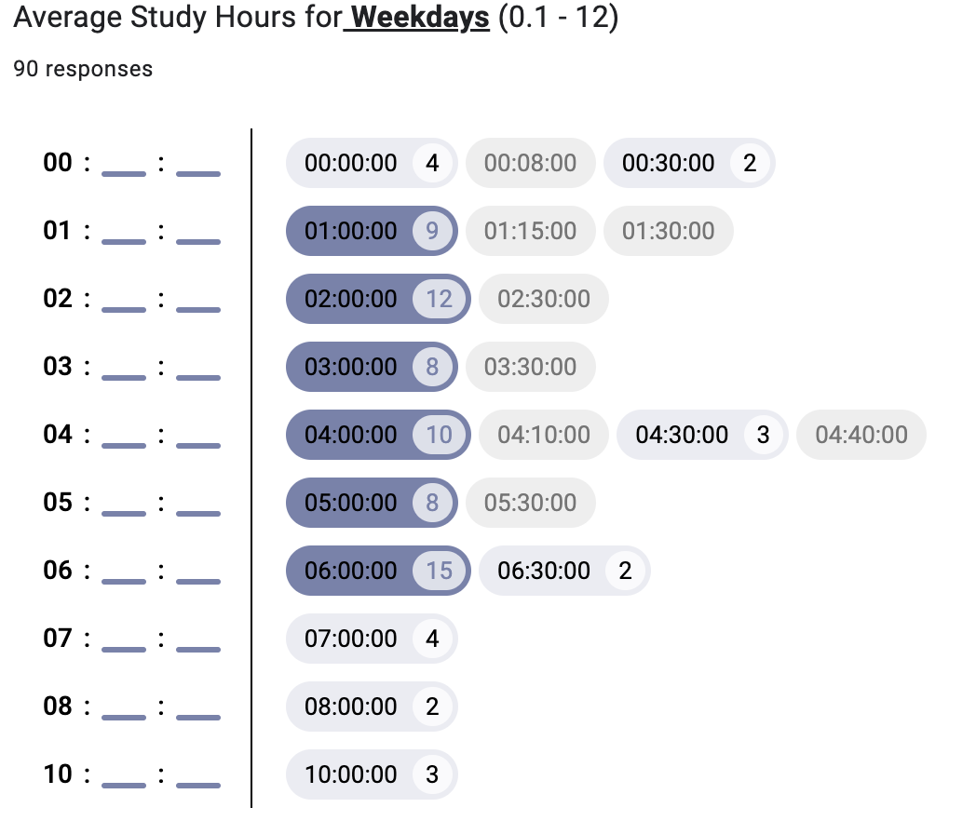  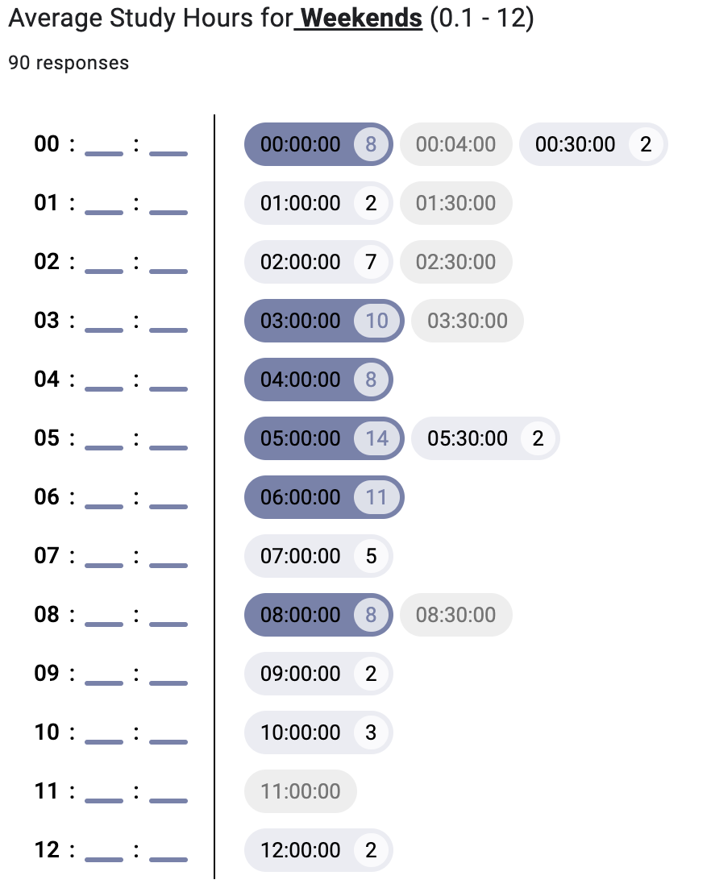 | The length of study on weekdays and weekends is entered into the Google form. because the Google form's user finds it challenging to complete the seven days. But weekends are free, the majority of individuals sleep properly on weekdays and properly on weekends.  Average study hours = (average study hours weekdays + average study hours weekends) / 2
Caffeine intake | 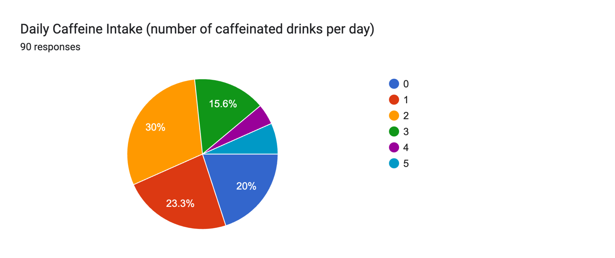 | According the this graph most of the students does not drink the caffeine.
Physical activity level | 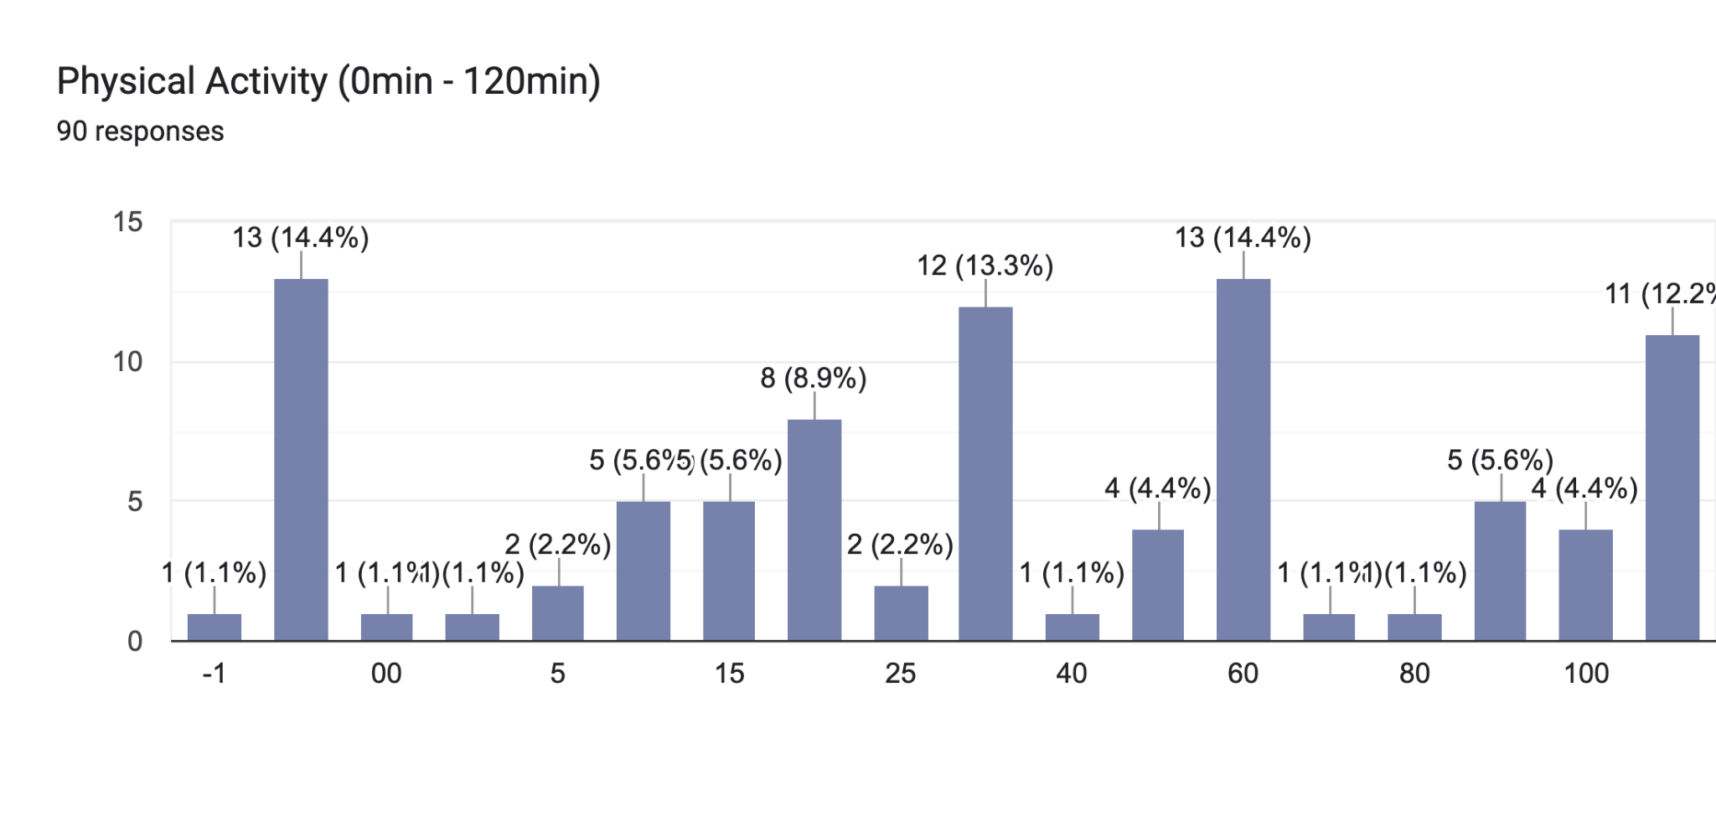 | According the graph most students physical activity level is 60.
Table 4: survey analyse table

4.5 Use Case Diagram

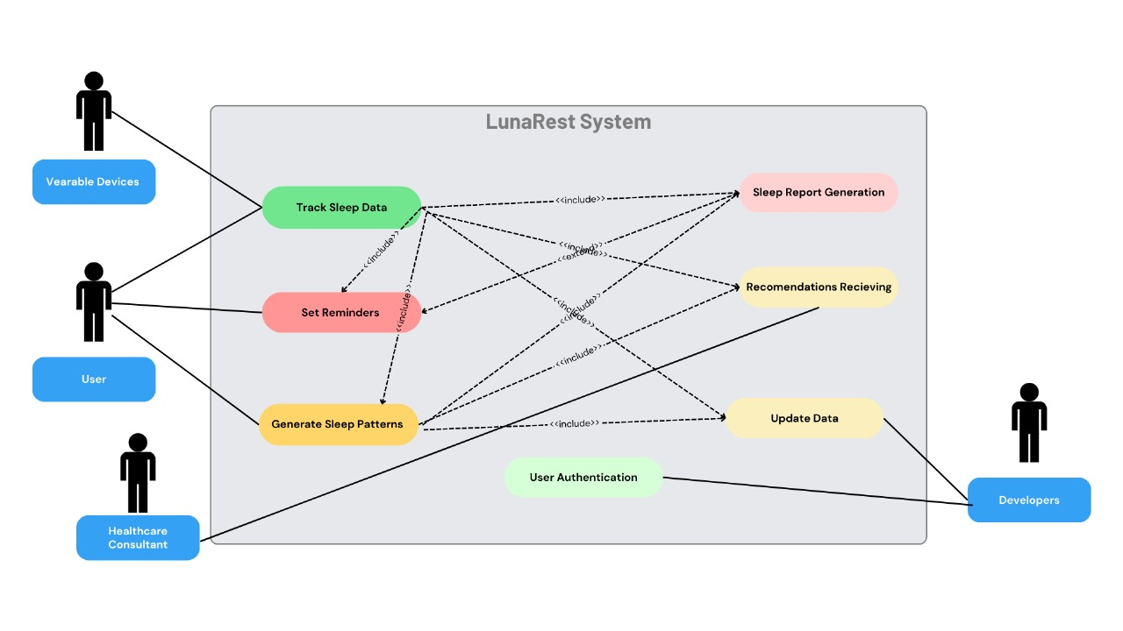
Figure2: LunaRest Diagram

4.6 Use Case Descriptions

Use Case Name | Track Sleep Data
Use Case ID | UC-001
Description | This can get input into the user’s sleep average.
Priority | High
Primary Actor | User
Supporting Actor | Wearable Devices
Pre-Conditions | The user must log in to the system  The user should give access to sleep data from wearable device
Trigger | The user should activate the wearable device
Main flow | Actors | System
 | user | Authenticate the user
Exception flow | Actors | System
 | user | If the wearable device is disconnected, give a notification to reconnect it.
Alternate flow | Actors | System
Exclusions | Data from unsupported wearable devices.
Post Conditions | Get the sleep data send it to the predict the sleep quality and stored this data
Table 5: Track sleep data use case table

Use Case Name | Set Reminders
Use Case ID | UC-002
Description | It allows user to personalized their bedtime, physical activity, and caffeine intake
Priority | Medium
Primary Actor | User
Supporting Actors | None
Pre-Conditions | The user must log in to the system.
Trigger | user should select the “Set Reminder” option
Main flow | Actors | System
 | User selects a reminder type like bedtime | Show the reminder customization and store reminders in the system.
Exception flow | Actors | System
 | User input is invalid | Display an error.
Alternate flow | Actors | System
 | The user requests reminder customization. | Updates reminder parameters based on user input.
Exclusions | Integration with calendar apps
Post Conditions | Reminders are activated then and the notification to the user.
Table 6: set reminders use case table
Use Case Name | Sleep Report Generator
Use Case ID | UC-003
Description | The app generates the details of user sleep patterns as a graph.
Priority | High
Primary Actor | User
Supporting Actors | None
Pre-Conditions | The user must be logged in to the system and input his data.
Trigger | Request the sleep report
Main flow | Actors | System
 | User calls report generation | Processing the sleep data and generating it on the screen.
Exception flow | Actors | System
 | User enter invalid data | Display a alert
Alternate flow | Actors | System
Exclusions | The user can not customize the graph template.
Post Conditions | Report is shown to the user.
Table 7: Sleep report generator use case table

Use Case Name | Recommendation Receiving
Use Case ID | UC-004
Description | The system provides recommendations to increase sleep quality and maintain the sleep quality
Priority | High
Primary Actor | User
Supporting Actors | Healthcare consultant
Pre-Conditions | The user should enter his data (sleep duration, study hours, etc.)
Trigger | Always predict the sleep quality it shows the recommendations
Main flow | Actors | System
 | User requesting the recommendations. | Analyze the sleep quality and display recommendations.
Exception flow | Actors | System
Alternate flow | Actors | System
Exclusions | Giving medical advice.
Post Conditions | The recommendations are saved in the database for the future.
Table 8: Recommendation receiving table

Use Case Name | Generate the sleep patterns
Use Case ID | UC-005
Description | Analyze the user's long-term sleep patterns.
Priority | High
Primary Actor | User
Supporting Actors | Developers
Pre-Conditions | The user should enter his data.
Trigger | The user should enter the “pattern analyse” option
Main flow | Actors | System
 | System generate the sleep patterns | Machine learning algorithms do that.
Exception flow | Actors | System
 | Incorrect data patterns generation. | Alert the user it is not sufficient data.
Alternate flow | Actors | System
Exclusions | Data correction option
Post Conditions | Sleep patterns are shown to the user and stored in the database.
Table 9: generate the sleep patterns use case table

Use Case Name | Update the data
Use Case ID | UC-006
Description | Users can update their old data
Priority | Medium
Primary Actor | User
Supporting Actors | Developers, wearable devices
Pre-Conditions | The user should enter his data first.
Trigger | Click the Update button
Main flow | Actors | System
 | The user updates the data | Updates the data on the database
Exception flow | Actors | System
Alternate flow | Actors | System
Exclusions | History data modification
Post Conditions | Data updated in the database.
Table 10: update the data use case table

Use Case Name | User Authentication
Use Case ID | UC-007
Description | Authenticate user to access the web app
Priority | High
Primary Actor | User
Supporting Actors | None
Pre-Conditions | The user should register an account and give the validated details(email).
Trigger | The user clicks the signup button
Main flow | Actors | System
 | The user enters his data | Validate the data and stored in the database
Exception flow | Actors | System
 | User enter invalid data | Display a error
Alternate flow | Actors | System
Exclusions | Register by social media or third-party platform.
Post Conditions | The user creates the account after the user goes to the home page.
Table 11: user authentication use case table

4.7 Functional Requirements (with prioritization)

Explanation of prioritization.
- Critical- The requirements that are critically needed in the successful completion
- Desirable – The requirements that can add value, but are not required immediately
- Luxury – The requirements that would add luxury to the system

Requirements list |  | Priority Level | Description
FR1 | User data input system | Critical | Allow users to input them data (e.g. user’s age, average sleep time, average study hours, caffeine intake etc.)
FR2 | Sleep quality scoring | Critical | Provide sleep quality score based in user inputs.
FR3 | Personalized recommendation | Critical | Offer advice to each user to improve their sleep quality score.
FR4 | Goal setting and scheduling | Desirable | User can edit the sleep their goals and sleep schedules.
FR5 | Sleep history and progress tracking | Desirable | User can get idea about his sleep history and he can know about his sleep quality is improved or not.
FR6 | Data Analytics Dashboard | Desirable | The user can understand his sleep patterns.
FR7 | Notification system | Luxury | This web app includes the notification for the bedtime and wakeup reminders.
FR8 | Customizing and Language Support | Luxury | Including the three main languages in SriLanka (sinhala,tamil, and english)for this app. And user can access to customize his screen to dark mode or light mode.
Table 12: Functional requirements table

4.8 Non- Functional Requirements

Requirements list |  | Priority Level | Description
NFR1 | performance | Critical | When the user gives the data to the form then within 2 seconds or minimum time, predict the sleep quality.
NFR2 | Security | Critical | All user's data must be protected during the transitions and the storage should protected.
NFR3 | Scalability | Luxury | The web app can be handled by 500+ users without any issues.
NFR4 | Usability | Critical | The user can accessible to the app by using minimum technical knowledge.
Table 13: Non functional table

4.9 Chapter Summary

This chapter primary focus was on identifying the project stakeholders, understanding their viewpoints, selecting the requirement elicitation techniques, and identifying the use case diagrams, and getting to know about functional and non-functional requirements.
Functional and non-functional requirements categorized based on the project’s objectives.
Stakeholders were shown by using Onion model, and give a viewpoint on their roles. And use case diagrams shows the web application core functionalities.

Chapter 5: Social, Legal, Ethical and Professional Issues

5.1 Chapter Overview
This section analyzes sociocultural, legal, moral, and professional aspects raised by the activities that involve the making and implementation of an artificial intelligence web-based application that enables forecasting, as well as the analysis of the sleeping patterns of university students. This project has implication for the collection of sensitive information from the users, predictive analysis-based techniques, and giving personal health advice. All these issues raised several ethical and legal concerns. In the next parts, these issues are addressed and the way to mitigate them in order to carry out responsible and law-abiding development are explained.

5.2 Dataset Ethical Clearance
Dataset source and description

The dataset used for this project, “Student sleep patterns”, was obtained from the Kaggle website. It includes data on ‘university students’ sleep duration, screen time, caffeine intake, physical activity, and student sleep quality.

- Dataset creator: Arsalan Jamal
- Dataset License: CC BY-SA 4.0 (Creative Commons Attribution-ShareAlike 4.0 International License)((Deed - Attribution-NonCommercial-ShareAlike 4.0 International - Creative Commons, n.d.))
- Dataset link: https://www.kaggle.com/datasets/arsalanjamal002/student-sleep-patterns

Additionally, collected the data from the IIT University and Sri Jayawardhanapura University students anonymously by the Google form.

5.3 SLEP Issues and Mitigation

5.3.1Overview
SLEP issues stand for social, Legal, Ethical, and Professional issues. This topic also discusses the sleep quality prediction classification domain’s ethical practice requirement and how to apply collected data without violating any of ethical guidelines and rules.

5.3.2 Social issues
This section discusses how the web app impacts to the society.
- This app is use for the improve the student's sleep quality and get better productivity. But some students can get thee anxiety about the sleep matrix.
- The project does not make for the multi-languages support.

5.3.3 Legal issues
This section discusses the project and compiles all relevant laws and regulations.
- The data privacy laws. Like GDPR, HIPAA, or CCPA (Plurilock Security, Inc., 2024). user’s sensitive information should be have the privacy.
- Assuring transparency of the system works and user data is handled.
- Intellectual property legitimacy and authorization with respect to software, dataset, or API.

5.3.4 Ethical issues
This section discusses project ethical issues. Such as Protecting the user's privacy and securing the data. There are no fake references or details in the research effort.

5.3.5 Professional issues
From the beginning to end research was conducted in professional manner. Research work was evaluated by a team of domain and technological experts in every step. Prototyping will done under confidentiality and protected using all the latest security measures to prevent any unauthorized access to it.

5.4 Chapter Summary
This chapter explains the SLEP issues in the project and how these challenges were solved through ethical practices, professional standards, etc.Such initiatives guarantee the fulfillment of the project’s objectives without compromising the rights and privacy of its users.

Chapter 6: System Architecture and Design

6.1. Chapter Overview
The system architecture and design are covered in this chapter. Author made some important choices when designing the system. This chapter makes these choices very clearly. Author used information from the chapter on system requirement specifications to make these important design decisions. This chapter covered other potential design choices.

6.2. System Architecture Design

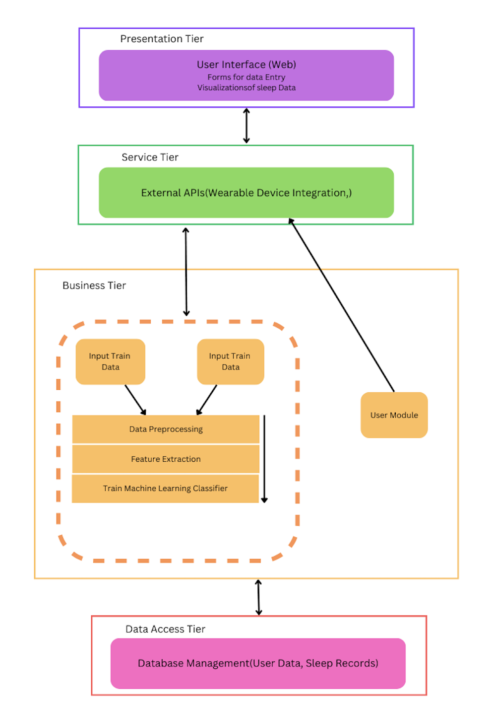
Figure 3: System Architecture Design

According to the tiered architecture diagram purposed system architecture consist of four layers. These layers are presentation tier, service tier, business tier and data access tier. Below contend explains each and every tier functionality and use.

6.2.1 Presentation tier
The web application user interface is designed to provide an intuitive engaging interface for user. University students enter their inputs like sleep duration, average study hours, etc. then view their sleep quality prediction and interact with tools like user sleep journals, and analytics dashboards.

6.2.2 Service tier

The Service Tier is the bridge for the presentation tier and the business tier. This layer handles the API requests and responses. When a user enters his data request and the service tier processes these API calls and retrieves the from the business tier and sends the data for the business tier.

6.2.3 Business tier

The business tier is the tier that holds all the backend logic. It contains the prediction and its training weight According to author's proposed system, the business tier contains data
preprocessing and feature extraction functionalities too. Well-structured business tier
shows the good coordination of business components of the system.

6.2.4 Data access tier
This tier stores the student sleep patterns dataset and all other bits of data that the system needs. Due to the nature of the project data is a crucial part of this system. Accuracy of
data and validation are required for the system to function perfectly.

6.3. System Design

6.3.1.Class Diagram/Data Flow Diagram (DFD)

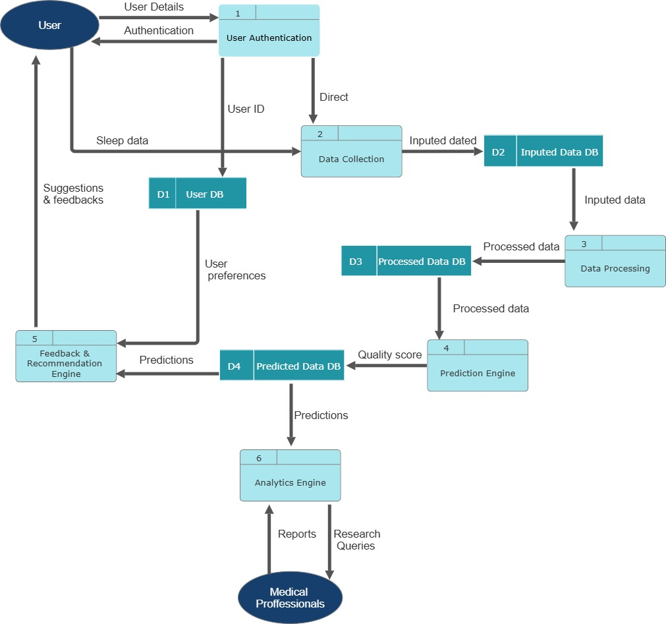
Figure 4: class diagram

6.3.2.Sequence Diagram

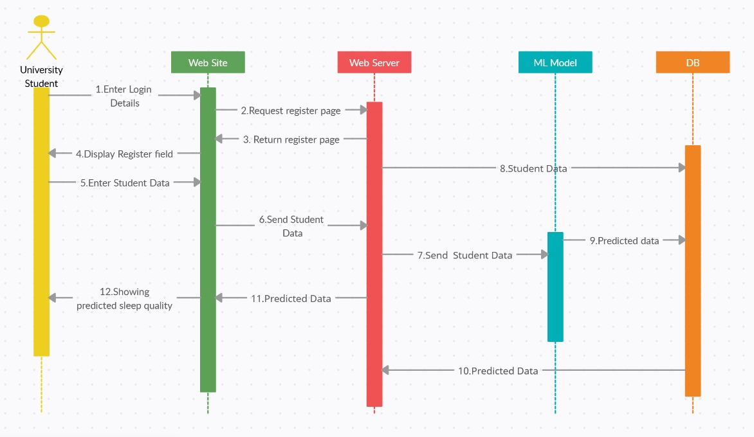

Figure 5:sequence diagram

6.3.3.UI Design and Mockups

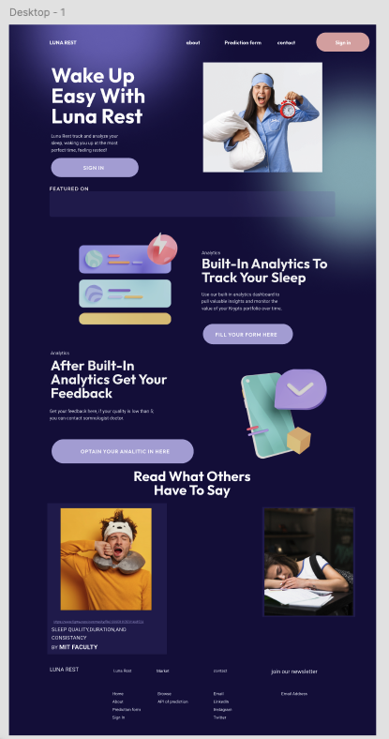
Figure 5: UI design diagram

6.3.4.Activity Diagram

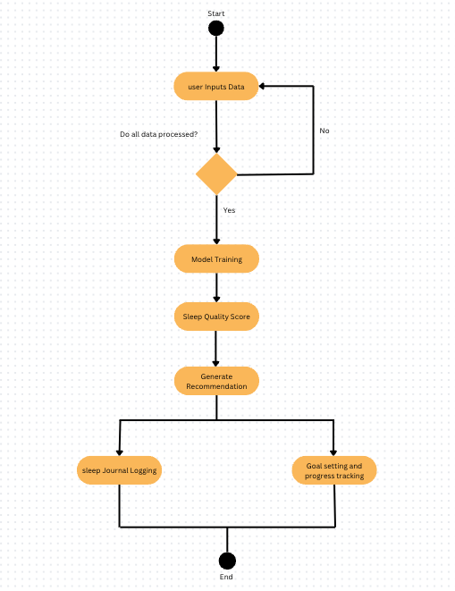
Figure 7: Activity diagram

6.4. Chapter Summary

This chapter covers design objectives, system architecture design, and system designs (class flow diagrams, sequence diagrams, UI Design, Activity diagrams) The structural design forms the basis of the systems architectural design, ensuring that both the functional and non-functional requirements are met in relation to the needs of university students.

References

- Plurilock Security, Inc. (2024, May 31). How GDPR, CCPA, HIPAA, and other data privacy standards safeguard our digital lives. Plurilock. https://plurilock.com/blog/how-gdpr-ccpa-hipaa-and-other-data-privacy-standards-safeguard-our-digital-lives/
- Deed - Attribution-NonCommercial-ShareAlike 4.0 International - Creative Commons. (n.d.). https://creativecommons.org/licenses/by-nc-sa/4.0/
- Student sleep patterns. (2024, October 14). Kaggle. https://www.kaggle.com/datasets/arsalanjamal002/student-sleep-patterns
- Sleepless nights? Let’s fix that! (n.d.). Google Docs. https://docs.google.com/forms/d/1aVbwY88AX7CctMUQ50c1M88WXA6HwIsU-Linr59j-aQ/edit

Appendix

Appendix A: Survey Questionaire

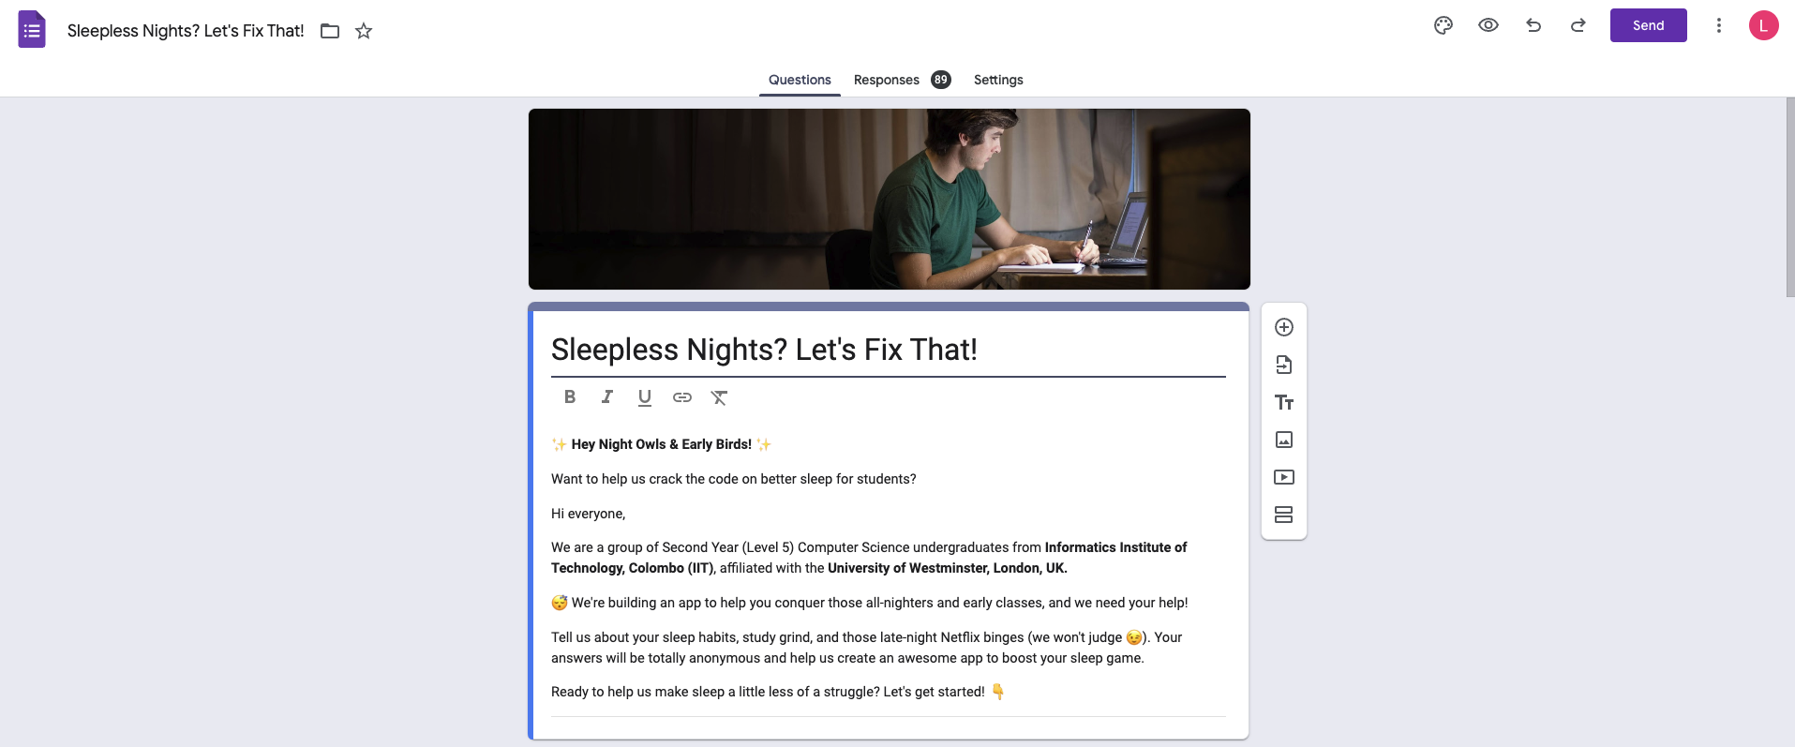

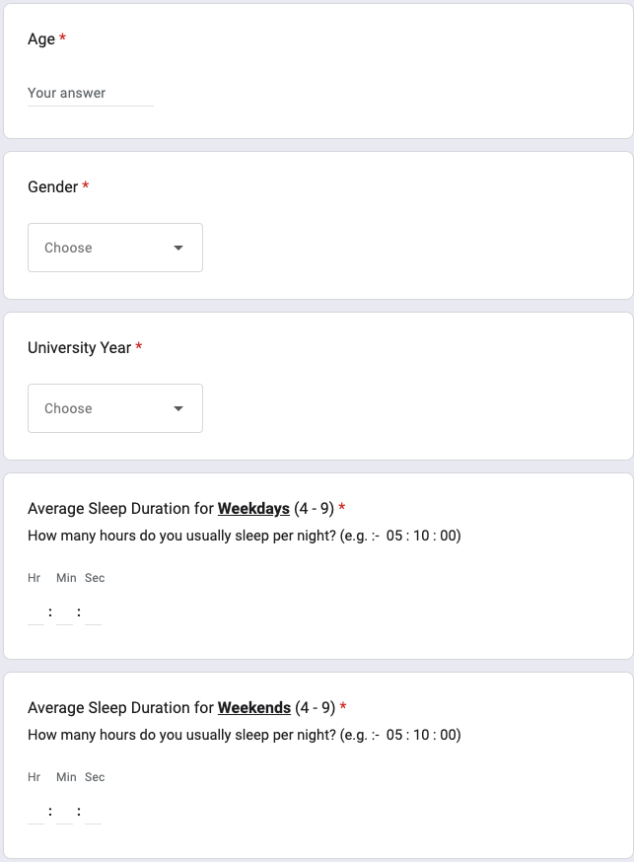
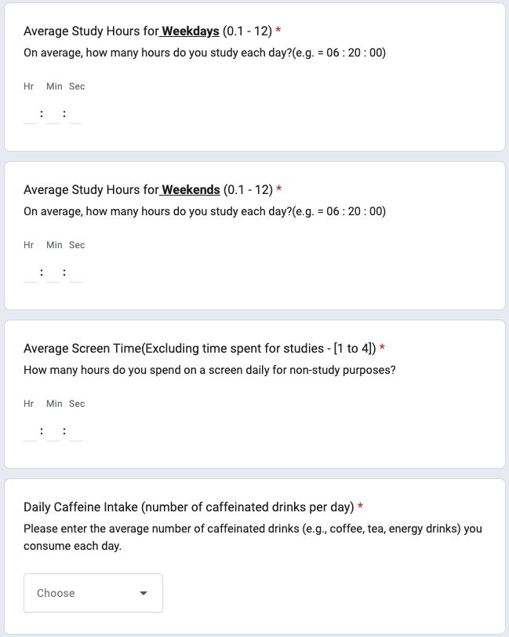
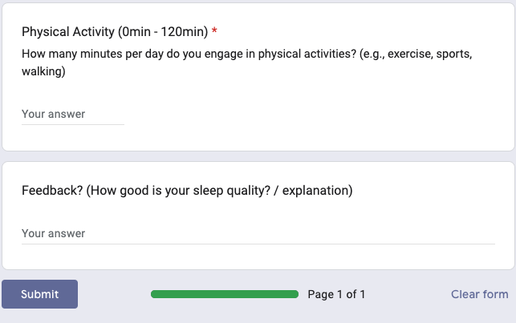
Figure 8: survey questioaire

Appendix B: Data Analysis Sample

Figure 9: Age analyse chart


Figure 10: University year anyalyse chart

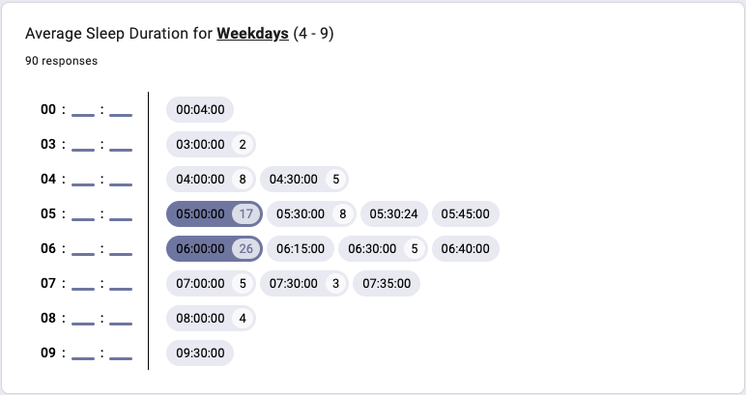
Figure 11: Average sleep duration in weekdays chart
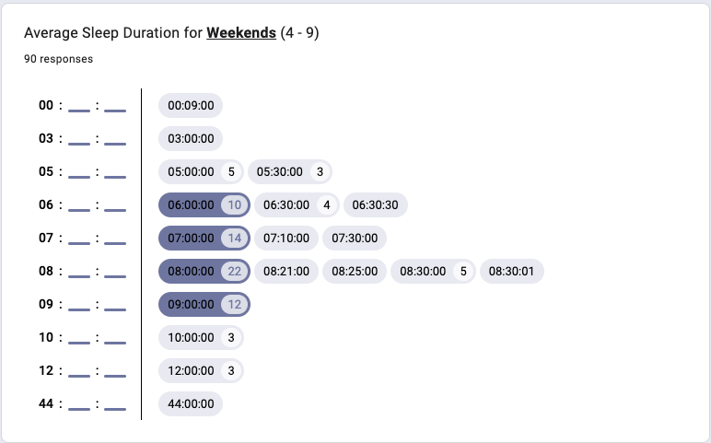
Figure 12: Average sleep duration in weekends chart
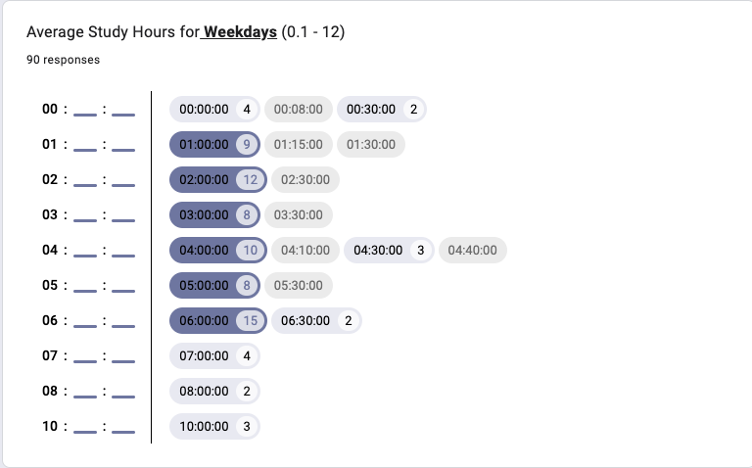
Figure 13: Average study hours in weekdays chart
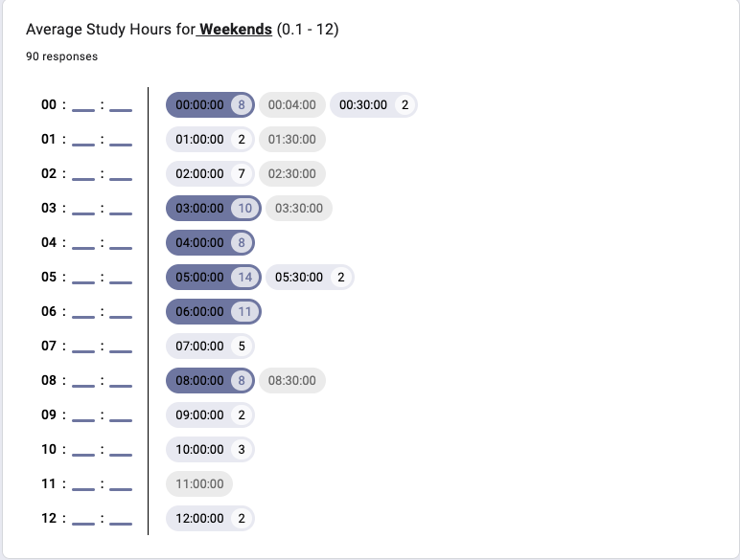
Figure 14: Average study hours in weekends chart

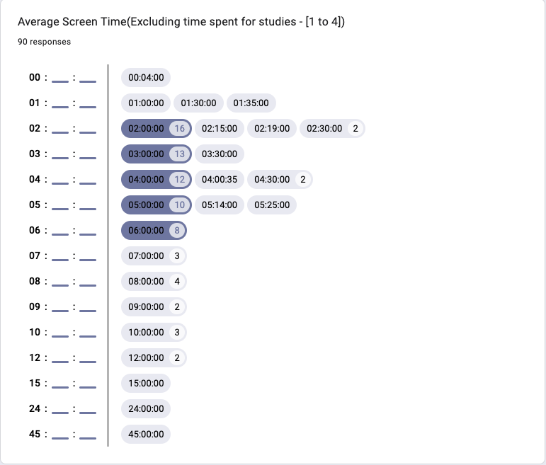
Figure 15: Average screen time chart


Figure 16: Daily caffeine intake chart


Figure 17: Physical activity level chart

Appendix C: Dataset Details
Details about the Kaggle dataset used:
- Name: Student Sleep Patterns
- Creator: Arsalan Jamal
- License: CC BY-SA 4.0
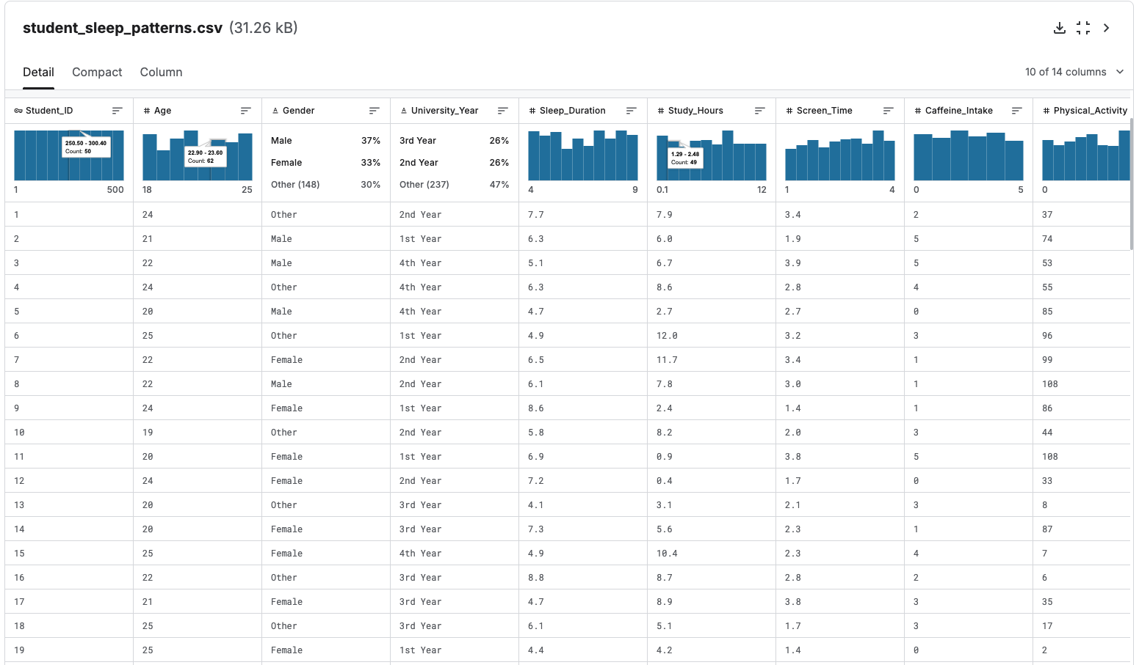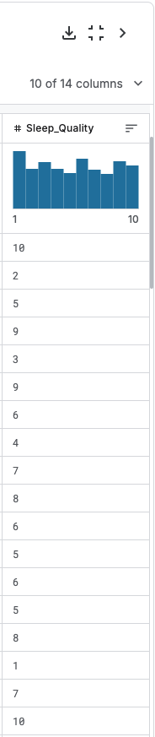
Figure 18: kaggle dataset

